Basic SQL Import Step

Objective:

It is used to import the data into selected table. The simplest way of importing the data into a table by using the SELECT...INFILE statement that imports a file data directly into a table on the server host.

## UI

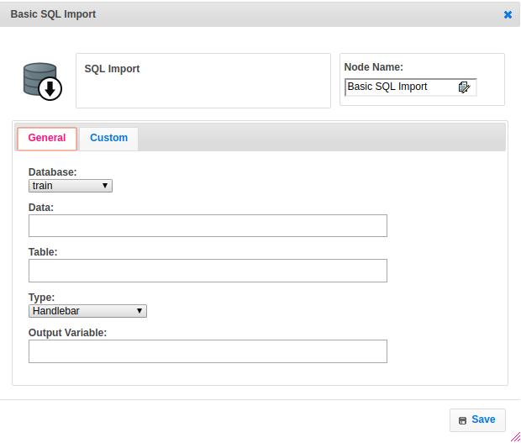

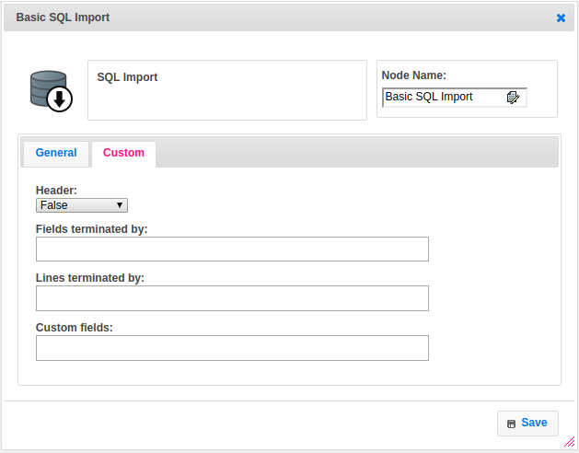

## Attributes:

|  |  |
| --- | --- |
| **Attributes** | **Description** |
| Type | To select type as free marker template or handlebar |
| Output Variable | Used to store the response of the step |
| Table | Table name to import the data based on the conditions from S3 bucket |
| Lines terminated by | If we specify a FIELDS clause, each of its subclauses (TERMINATED BY, [OPTIONALLY] ENCLOSED BY, and ESCAPED BY) is also optional, except that you must specify at least one of them. Arguments to these clauses are permitted to contain only ASCII characters. For Lines terminated we can give for example \r\n to terminate the line |
| Data | The data which we get from the previous step to import into the given table |
| Fields terminated by | If we specify a FIELDS clause, each of its subclauses (TERMINATED BY, [OPTIONALLY] ENCLOSED BY, and ESCAPED BY) is also optional, except that you must specify at least one of them. Arguments to these clauses are permitted to contain only ASCII characters. For Fields terminated we can give for example (,) to terminate the fields |
| Header | Header mappings are used to map the columns which provided by user to import. If header is false then includes the headers else excludes the headers, by default it is false |
| Custom fields | Custom fields are always optional fields. If we want to import data into a particular fields then we should need to enable the Header. This means that you can use a custom field without requiring existing issues to be changed. |
| Database | The name of the plugin which we configured earlier with server, username, password and schema |

## Executor Description:

* In executor class first will get the data as a string and then convert from string to byte.
* Creates a temporary file and write the byte data into that file by using fileoutputstream then set the delimiter.
* Connect to mysql server by using mysql plugin then Import the csv data into a table which given by user. If user select header as true then exclude headers otherwise it include headers, by default it is false. User can add custom fields and also user can terminate lines as well fields based on requirement.
* After importing data into table successfully will delete the temporary file before exit and returns success.

## Dependent plugins:

|  |  |
| --- | --- |
| **Attributes** | **Description** |
| server | The host name "localhost" might resolve to "127.0.0.1" or "::1" on your host, so note this when checking permissions. For example, if a web application's user only has access to "127.0.0.1" on a host, and a defined connection uses "localhost" that resolves to "::1", this connection may lack the proper permissions to the aforementioned web application. User can provide another server url when they want to connect with their host. |
| username | Username to use for the connection. For localhost default is root. |
| password | Optional password for the account used. If you enter no password here, you will be prompted to enter the password when MySQL Workbench attempts to establish the connection. MySQL Workbench can store the password in a vault. |
| schema | When the connection to the server is established, this is the schema that will be used by default. It becomes the default schema for use in other parts of MySQL Workbench |

## Resource:

For more information please refer the below link

<https://dev.mysql.com/doc/>